UNITED STATES
SECURITIES AND EXCHANGE COMMISSION
Washington, D.C. 20549

SCHEDULE 14A

Proxy Statement Pursuant to Section 14(a) of
the Securities Exchange Act of 1934 (Amendment No. )

Filed by the Registrant ☒
Filed by a Party other than the Registrant ☐
Check the appropriate box:
☐ | Preliminary Proxy Statement
☐ | Confidential, for Use of the Commission Only (as permitted by Rule 14a-6(e)(2))
☐ | Definitive Proxy Statement
☒ | Definitive Additional Materials
☐ | Soliciting Material under §240.14a-12

LIVERAMP HOLDINGS, INC.
(Name of Registrant as Specified In Its Charter)

(Name of Person(s) Filing Proxy Statement, if other than the Registrant)

Payment of Filing Fee (Check the appropriate box):

☒ | No fee required.
☐ | Fee paid previously with preliminary materials.
☐ | Fee computed on table in exhibit required by Item 25(b) per Exchange Act Rules 14a-6(i)(1) and 0-11.

On August 3, 2026, LiveRamp Holdings, Inc. sent the below internal communication to its employees.

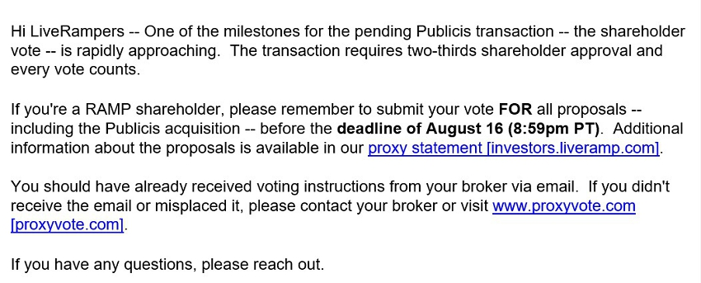

Forward-Looking Statements

This communication contains forward-looking statements within the meaning of, and subject to the protections of, Section 27A of the Securities Act of 1933, as amended, and Section 21E of the Securities Exchange Act of 1934, as amended, concerning Publicis, LiveRamp, the proposed transaction and other matters. Forward-looking statements contained herein could include, among other things, statements regarding the anticipated timing of the consummation of the proposed transaction; statements about management’s confidence in and strategies for performance of the combined businesses; expectations for new and existing products, technologies and opportunities; and expectations regarding growth, sales, cash flows, and earnings. Forward-looking statements can be identified by the use of such terms as “may,” “could,” “expect,” “anticipate,” “intend,” “believe,” “likely,” “estimate,” “outlook,” “plan,” “contemplate,” “project,” “target” or other comparable terms. These forward-looking statements are not guarantees of future performance. Actual results may differ materially from the forward-looking statements as a result of a number of risks and uncertainties, many of which are outside the parties’ control. Many factors could cause actual future events to differ materially from the forward-looking statements in this communication including, but not limited to: (1) failure of the closing conditions in the merger agreement to be satisfied, or any unexpected delay in closing the proposed transaction or the occurrence of any event, change, or other circumstance that could give rise to the right of one or multiple of the parties to terminate the definitive agreement between Publicis and LiveRamp; (2) the possibility that the transaction does not close when expected or at all because required regulatory, shareholder, or other approvals are not received or satisfied on a timely basis or at all; (3) the possibility that the transaction may be more expensive to complete than anticipated, including as a result of unexpected factors or events, including those resulting from the announcement, pendency or completion of the transaction; (4) risks that the new businesses will not be integrated successfully or that the combined companies will not realize estimated cost savings, value of certain tax assets, synergies and growth or that such benefits may take longer to realize than expected; (5) failure to realize anticipated benefits of the combined operations; (6) risks relating to unanticipated costs of integration; (7) ability to hire and retain key personnel; (8) ability to successfully integrate the companies’ businesses; (9) the potential impact of announcement or consummation of the proposed transactions on relationships with third parties, including clients, employees and competitors, including reputational risk; (10) ability to attract new clients and retain existing clients in the manner anticipated; (11) reliance on and integration of information technology systems; (12) suffering reduced profits or losses as a result of intense competition; or (13) potential litigation that may be instituted against LiveRamp or its directors or officers related to the proposed transaction or the merger agreement. The foregoing list of factors is not exhaustive. You should carefully consider the foregoing factors and the other risks and uncertainties that affect the parties’ businesses, including those described in LiveRamp’s Annual Report on Form 10-K for the year ended March 31, 2026, in Part I “Cautionary Statements Relevant to Forward-Looking Information” and Part I, Item 1A, “Risk Factors,” as updated by subsequent Quarterly Reports on Form 10-Q, which are filed with the Securities and Exchange Commission (the “SEC”) and those described in documents Publicis has filed with the Autorité des Marchés Financiers (the French securities regulator). The parties do not undertake, nor do they have, any obligation to provide updates or to revise any forward-looking statements.

NO OFFER OR SOLICITATION

This communication does not constitute an offer to sell or the solicitation of an offer to buy any securities or a solicitation of any vote or approval, nor shall there be any sale of securities in any jurisdiction in which such offer, solicitation or sale would be unlawful prior to registration or qualification under the securities laws of any such jurisdiction. No offer of securities shall be made except by means of a prospectus meeting the requirements of Section 10 of the Securities Act of 1933, as amended, and applicable regulations.

ADDITIONAL INFORMATION AND WHERE TO FIND IT

In connection with the proposed transaction, LiveRamp Holdings, Inc. filed a definitive proxy statement with the SEC relating to the proposed transaction on July 6, 2026 (the “proxy statement”). LiveRamp commenced mailing of the proxy statement to its shareholders on or about July 8, 2026. This communication is not a substitute for the proxy statement or any other document that LiveRamp has filed or may file with the SEC in connection with the proposed transaction. BEFORE MAKING ANY VOTING DECISION, INVESTORS AND SECURITY HOLDERS ARE URGED TO READ THE PROXY STATEMENT AND ANY OTHER DOCUMENTS THAT ARE FILED OR WILL BE FILED WITH THE SEC IN CONNECTION WITH THE PROPOSED TRANSACTION OR INCORPORATED BY REFERENCE IN THE PROXY STATEMENT WHEN THEY BECOME AVAILABLE WITH THE SEC BECAUSE THEY CONTAIN OR WILL CONTAIN IMPORTANT INFORMATION ABOUT THE PROPOSED TRANSACTION. Any vote in respect of resolutions to be proposed at LiveRamp’s shareholder meeting to approve the proposed transaction should be made only on the basis of the information contained in LiveRamp’s proxy statement and documents incorporated by reference therein. Investors and security holders may obtain free copies of these documents (when they are available) and other related documents filed with the SEC at the SEC’s website at www.sec.gov or on LiveRamp’s website at www.liveramp.com.

PARTICIPANTS IN THE SOLICITATION

Publicis, LiveRamp and their respective directors and certain of their respective executive officers may be deemed to be participants in the solicitation of proxies from the shareholders of LiveRamp in respect of the proposed transactions contemplated by the proxy statement. Information regarding the persons who are, under the rules of the SEC, participants in the solicitation of the shareholders of LiveRamp in connection with the proposed transaction, including a description of their direct or indirect interests, by security holdings or otherwise, is set forth in the proxy statement. Information about the directors and executive officers of LiveRamp and their ownership of shares of LiveRamp common stock and other securities of LiveRamp can be found in the sections entitled “Nominees and Continuing Directors,” “Compensation Discussion and Analysis,” “Compensation Tables,” “Non-Employee Director Compensation” and “Security Ownership of Certain Beneficial Owners and Management” included in the proxy statement; in the Form 3 and Form 4 initial statements of beneficial ownership and statements of changes in beneficial ownership filed with the SEC by LiveRamp’s directors and executive officers; and in other documents subsequently filed by LiveRamp with the SEC. Investors and security holders may obtain free copies of these documents and other related documents filed with the SEC at the SEC’s website at www.sec.gov or on LiveRamp’s website at www.liveramp.com.

